

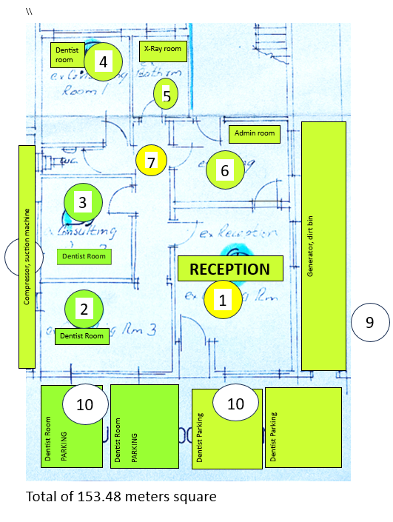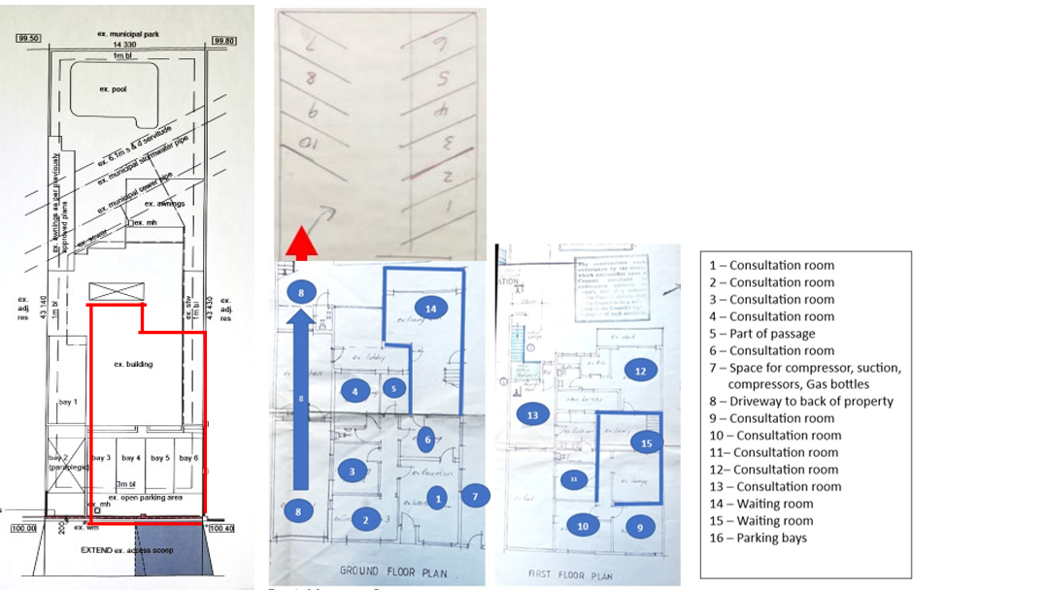

**NB :** rezoning of property is in the process. A drive way will extend to the back through the existing kitchen, the pool will be closed and an additional 10 parking bays created, one waiting room downstairs, one waiting upstairs and 5 consulting rooms upstairs. The down stairs reception room will become a consulting room